Abstract No: (for official use only) Type your Theme here.

TYPE THE TITLE OF THE ABSTRACT HERE IN BOLD UPPERCASE LETTERS AND CENTER ALIGNED

The extended abstract must contain the introduction, materials and methods, results and discussion, conclusions, and references.
This is the format of the extended abstract. You can delete the content provided in this template and replace it with the text and figures of your abstract.
Please follow Guidelines for Preparing Abstracts and Extended Abstracts. Follow the APA style (Madigan, 1995) for citing references.
Use Times New Roman and 11 font size.

Introduction

The introduction section should (1) introduce your study, the research gap filled together with novelty, and the research problem, (2) present the scope and objective of the study, (3) briefly review the pertinent literature, and (4) provide a research frame.

Materials and Methods
Information on materials purchased/used and how the solutions were prepared should be included. If sampling was done, details of sampling procedure should be stated. Methods applied in research must be clearly stated and described in sufficient detail or supported with appropriate references. The explanation should highlight why the chosen method(s) are appropriate for addressing the research problem.
If you submit an abstract in pure mathematics, this section should be named Preliminaries, and it should include the definitions and the results that you have used from other literature, with references given clearly.

Results and Discussion

Results together with appropriate discussion should be given in detail in this section. Tables, images and figures should be centered.
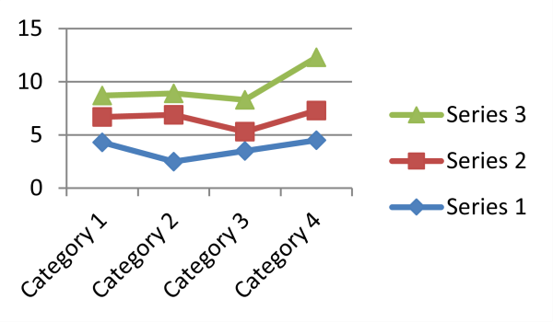
Tables and Figures should be numbered sequentially (e.g. see Figure 2). Figure captions should be placed under the figure or image. Tables should also be numbered, with table header placed above the table. Any references related to tables, figures or images should be provided directly below them, using the author’s lastname and publication year.

Figure 2. Header
1

If you submit an abstract in pure mathematics, this section should include the statements and proofs of the main theorems.

Conclusion

The conclusion should cover the main findings of the study and any relevant recommendations.

References
- Madigan, R. J. (1995). The language of psychology: APA style as epistemology.
American Psychologist, 50(6), 428-435.

- Bazerman, C. (1981). What written knowledge does: Three examples of academic discourse. Philosophy of the Social Sciences, 11(3), 361- 387.

2

